All lives matter, the most endangered matter more urgently
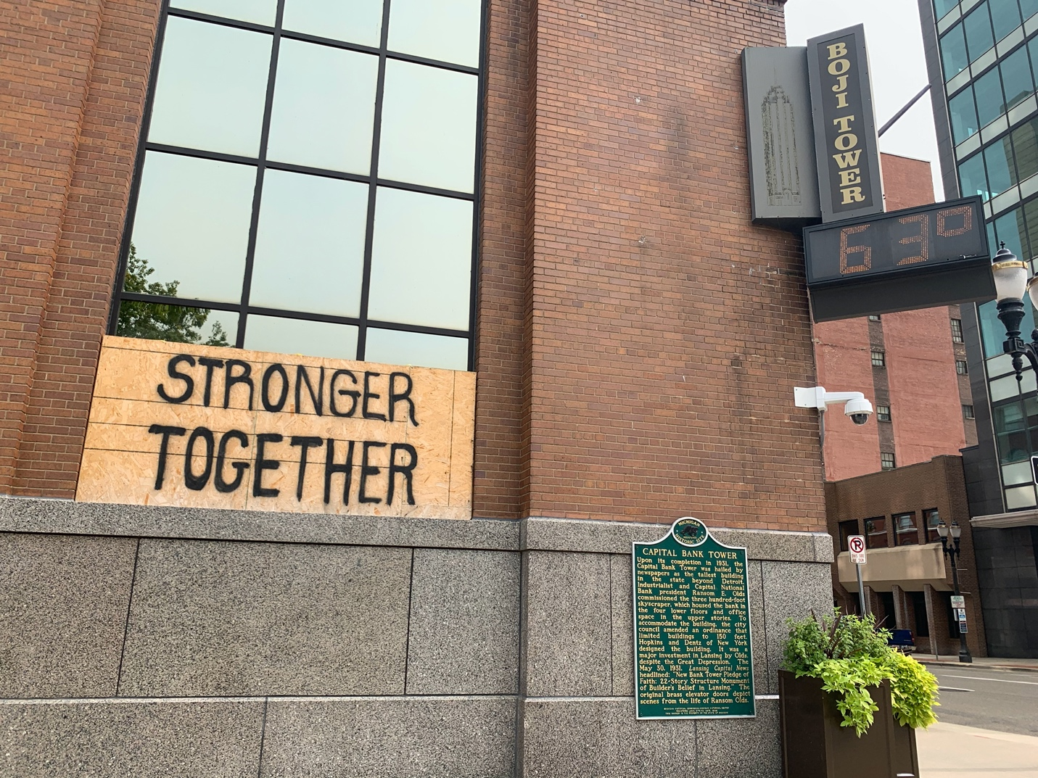

The motion resonates. There is so much good out there. We only need to embrace it within ourselves, we all want peace, we all deserve equity. We are stronger together. Divided we fall.
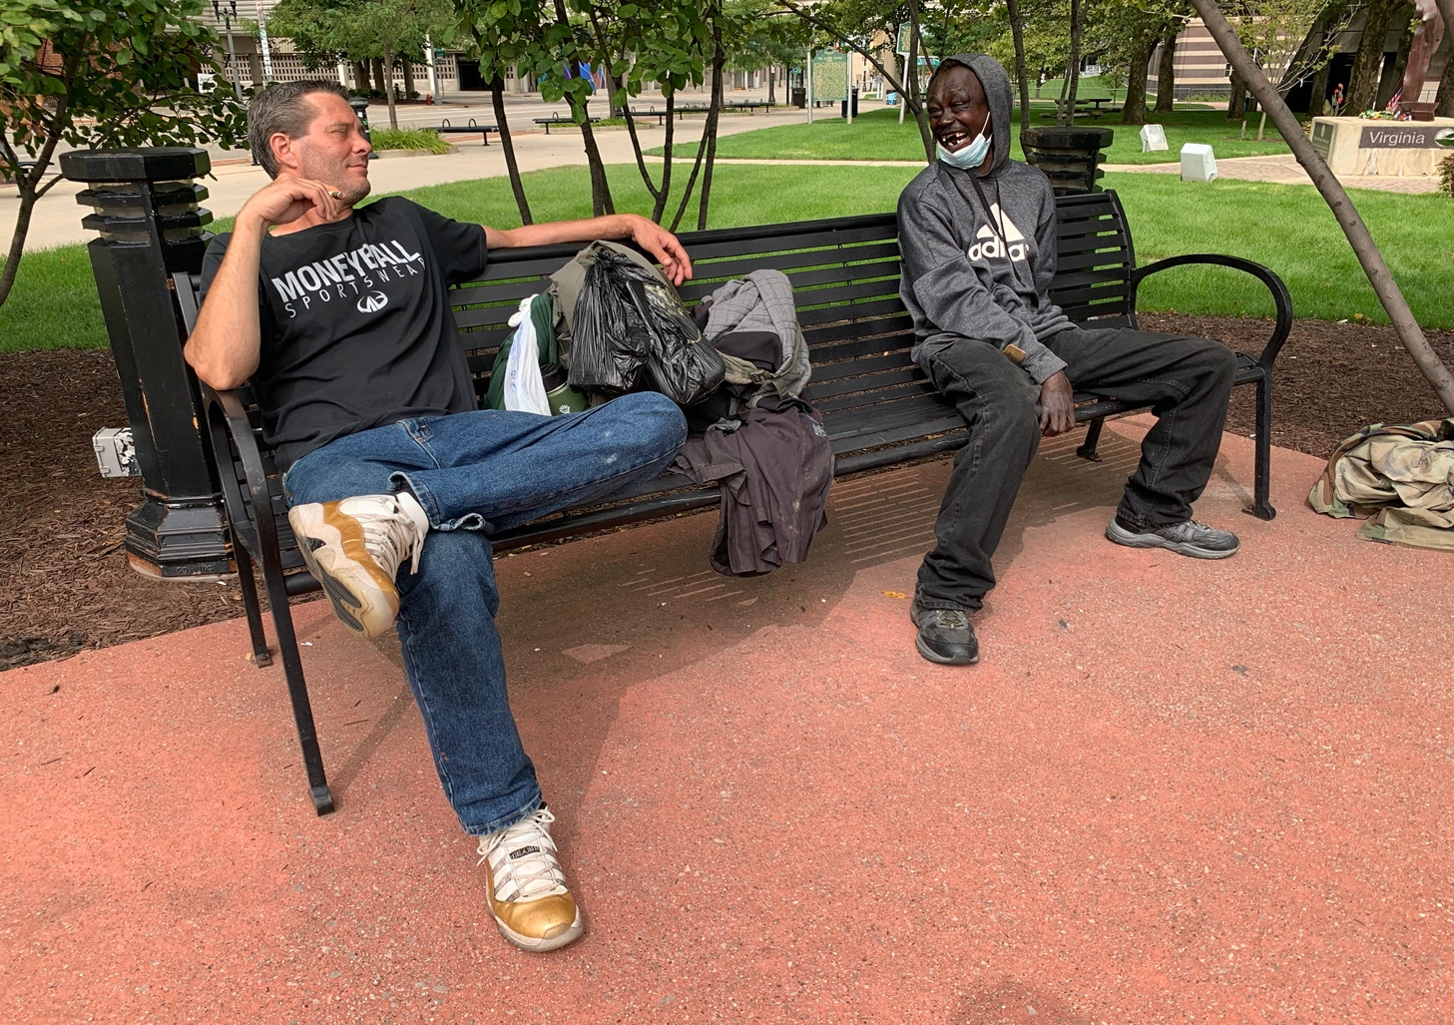

It takes two, no matter the race, to share a good joke. -Downtown Lansing
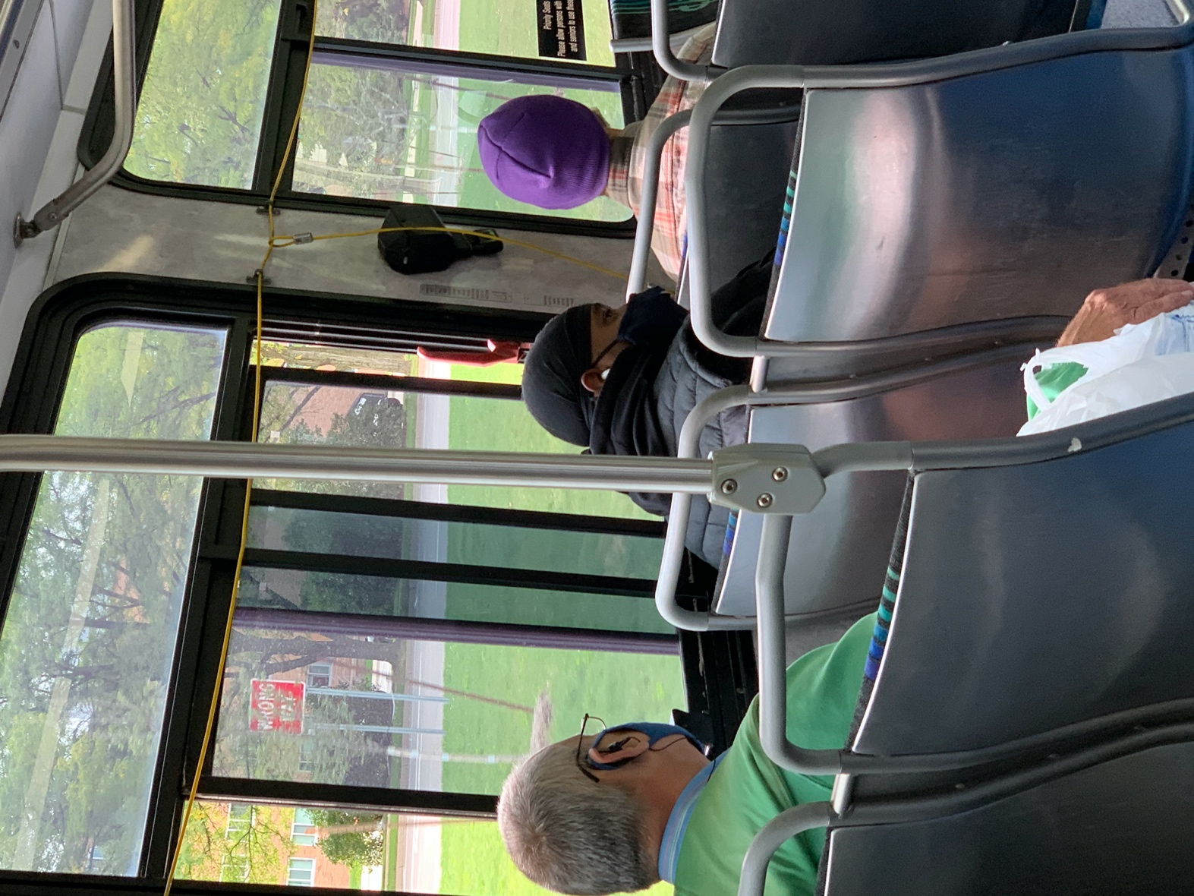

There can be a world, where color is beautiful, and peaceful.
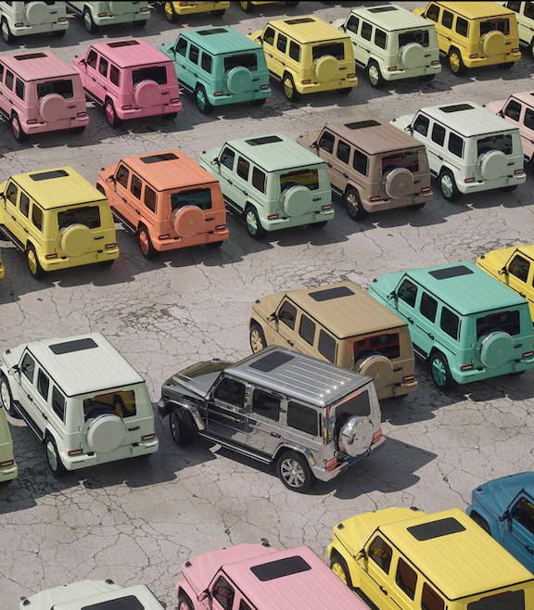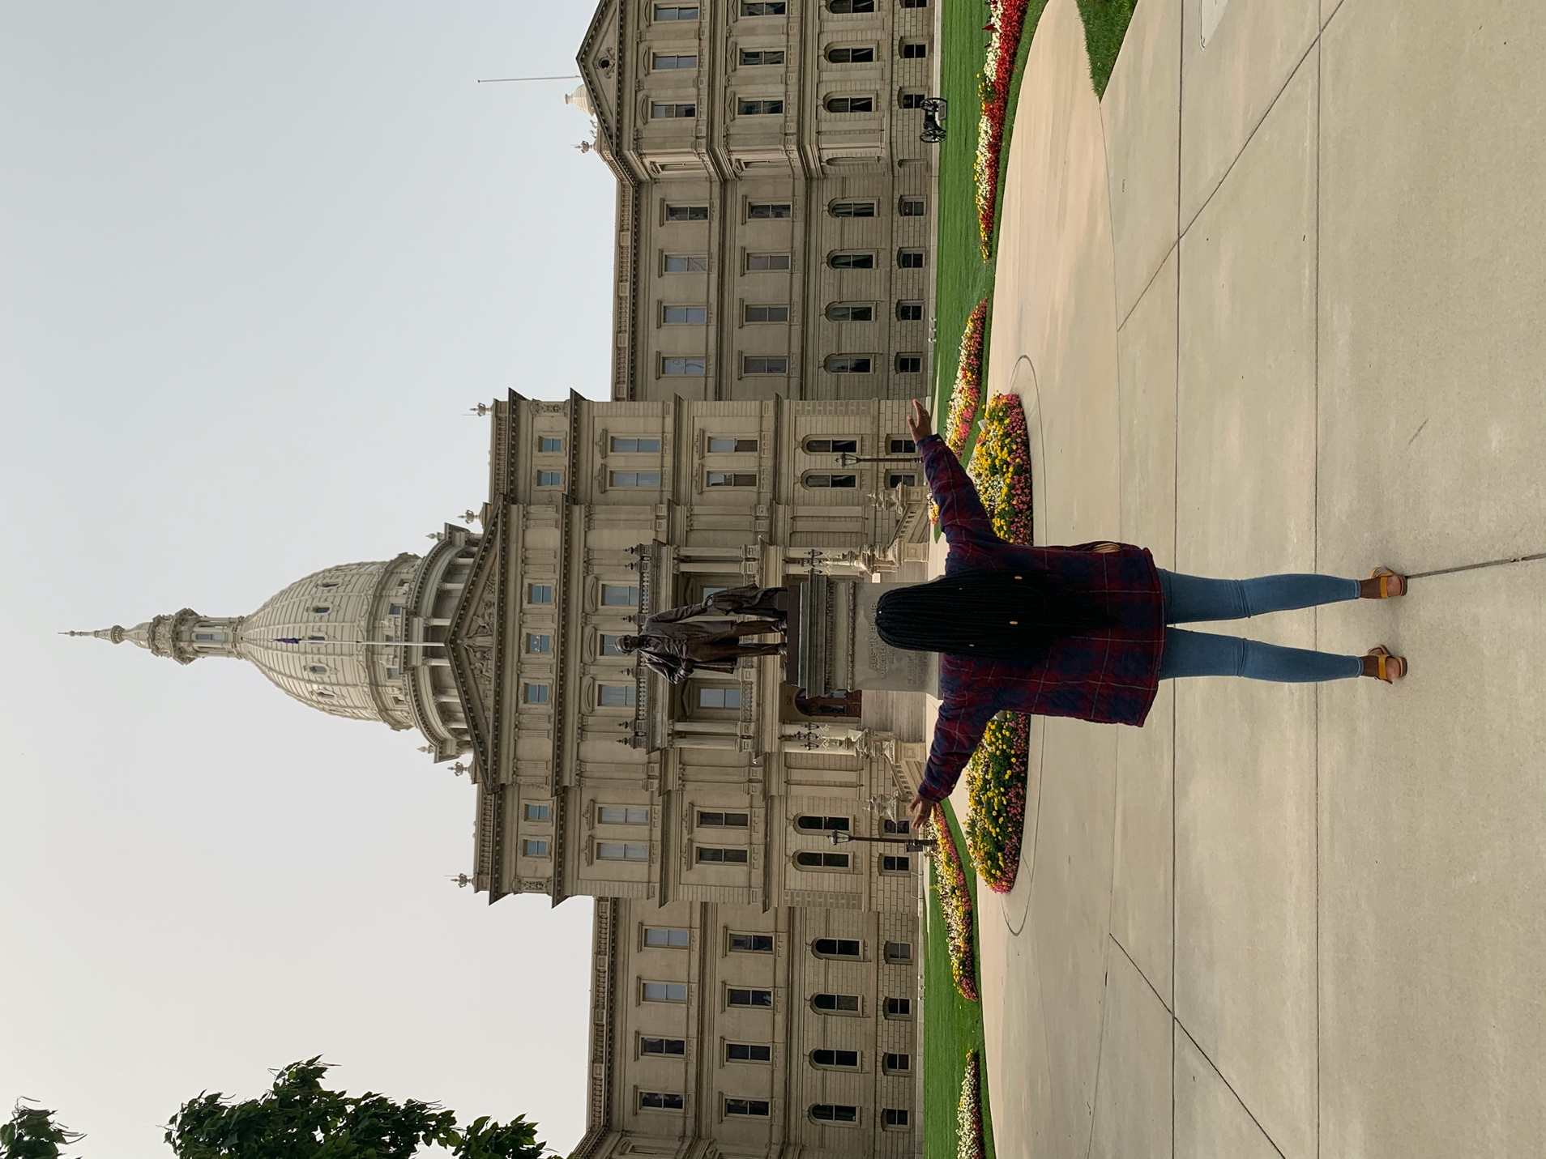
Natalie Kagole at the Lansing Capitol
MY STORY
I chose the theme of equity and anti-oppression because it is a core human rights issue. In my opinion, Human Rights should not even be a discussion, rather a general consensus because everyone is human, and everyone would like to be treated fairly. However, we still have particular instances and events in which equity, and in this case racial equity and anti-oppression has not been prioritized or where we as a society have failed to address.

My visuals are candid photos taken at locations in the Lansing District. My hope is that they can evoke the emotion of empathy, but most importantly, to see the good, what the world can be when these basic ideals are embraced. When equity, in this case, racial equity is achieved. My life has always been one dedicated to the grassroots. I came into this country as a freshman, young, African, woman of color in the United States. Though it has only been three years, I have tirelessly focused on using my “objective” advantage, a term that I coined myself, to bridge racial gaps within my African American and White American friends. I say objective advantage because, as a foreign student, when I point out positive ways in which we can come together regardless of race, or when I bring to light that I have faced microaggressions and racism, I am listened to. This is because, my lens is presumed more likely “objective’ since I have not actively suffered the historical traumas that people of my skin color may have. I have since capitalized on this “advantage” to paint the picture of what a positive world could do.

In my visuals, I end with two photos. One of a bunch of cars, of different colors, but one car finding it difficult to fit in the model, these are the minorities, we are all beautiful, and functional, and can look fabulous if we help that one car, fit through equity. The second photo is of the Lansing Capitol. This is because policy is one of the more tangible ways of ensuring that everyone receives equity and anti-oppression can cease. Yes, we can. We are stronger together.

